POC Instant Payments Solution design

System Diagram for the Payment Processing System.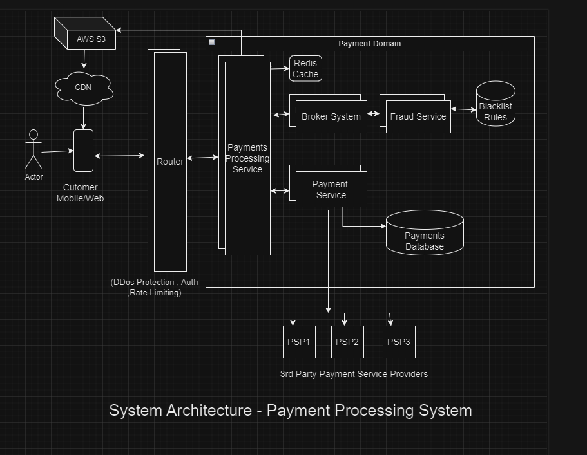

Sequence / Activity Diagram

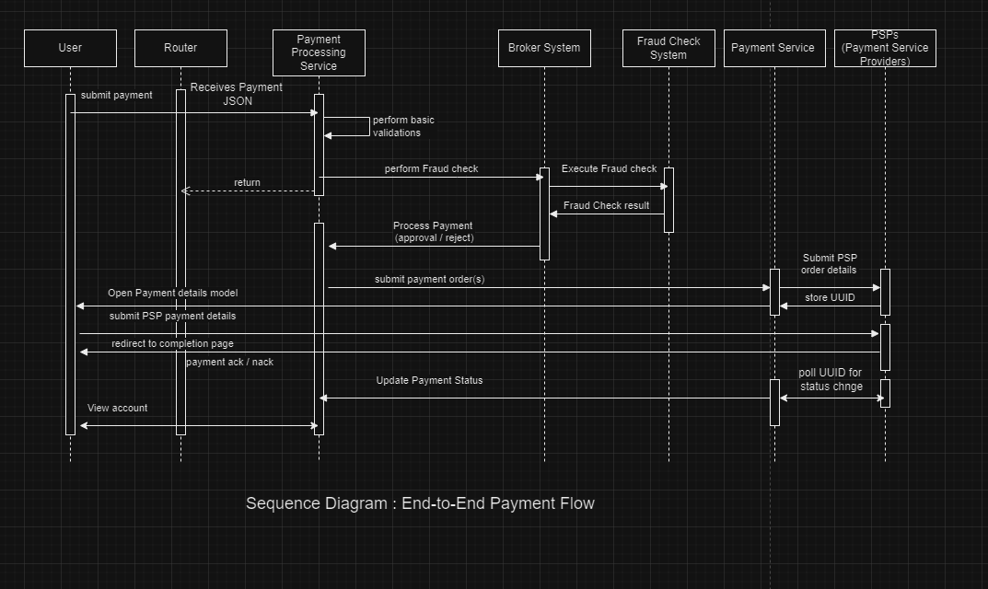

Sample JSON for testing the Microservice application

JSON for testing the application

1. Valid Payment (Should be Approved)

JSON

{  
 "transactionId": "11111111-1111-1111-1111-111111111111",  
 "payerName": "Alice Johnson",  
 "payerBank": "Bank of America",  
 "payerCountryCode": "USA",  
 "payerAccount": "1234567890",  
 "payeeName": "Bob Smith",  
 "payeeBank": "BNP Paribas",  
 "payeeCountryCode": "FRA",  
 "payeeAccount": "9876543210",  
 "paymentInstruction": "Loan Repayment",  
 "executionDate": "2025-08-01",  
 "amount": 500.00,  
 "currency": "USD",  
 "creationTimestamp": "2025-08-01T10:30:00Z"  
}

 2. Blacklisted Payer Name (Should be Rejected)

JSON

{  
 "transactionId": "22222222-2222-2222-2222-222222222222",  
 "payerName": "Mark Imaginary",  
 "payerBank": "Chase Bank",  
 "payerCountryCode": "USA",  
 "payerAccount": "1234567891",  
 "payeeName": "Bob Smith",  
 "payeeBank": "BNP Paribas",  
 "payeeCountryCode": "FRA",  
 "payeeAccount": "9876543211",  
 "paymentInstruction": "Invoice Payment",  
 "executionDate": "2025-08-01",  
 "amount": 1000.00,  
 "currency": "USD",  
 "creationTimestamp": "2025-08-01T10:35:00Z"  
}

3. Blacklisted Payee Name (Should be Rejected)

JSON

{  
 "transactionId": "33333333-3333-3333-3333-333333333333",  
 "payerName": "Alice Johnson",  
 "payerBank": "Chase Bank",  
 "payerCountryCode": "USA",  
 "payerAccount": "1234567892",  
 "payeeName": "Govind Real",  
 "payeeBank": "BNP Paribas",  
 "payeeCountryCode": "FRA",  
 "payeeAccount": "9876543212",  
 "paymentInstruction": "Salary Payment",  
 "executionDate": "2025-08-01",  
 "amount": 1200.00,  
 "currency": "USD",  
 "creationTimestamp": "2025-08-01T10:40:00Z"  
}

4. Blacklisted Payer Country (Should be Rejected)

JSON

{  
 "transactionId": "44444444-4444-4444-4444-444444444444",  
 "payerName": "Alice Johnson",  
 "payerBank": "Chase Bank",  
 "payerCountryCode": "CUB",  
 "payerAccount": "1234567893",  
 "payeeName": "Bob Smith",  
 "payeeBank": "BNP Paribas",  
 "payeeCountryCode": "FRA",  
 "payeeAccount": "9876543213",  
 "paymentInstruction": "Bonus Payment",  
 "executionDate": "2025-08-01",  
 "amount": 700.00,  
 "currency": "USD",  
 "creationTimestamp": "2025-08-01T10:45:00Z"  
}

5. Blacklisted Payee Country (Should be Rejected)

JSON

{  
 "transactionId": "55555555-5555-5555-5555-555555555555",  
 "payerName": "Alice Johnson",  
 "payerBank": "Chase Bank",  
 "payerCountryCode": "USA",  
 "payerAccount": "1234567894",  
 "payeeName": "Bob Smith",  
 "payeeBank": "BNP Paribas",  
 "payeeCountryCode": "IRN",  
 "payeeAccount": "9876543214",  
 "paymentInstruction": "Refund",  
 "executionDate": "2025-08-01",  
 "amount": 300.00,  
 "currency": "USD",  
 "creationTimestamp": "2025-08-01T10:50:00Z"  
}

6. Blacklisted Payer Bank (Should be Rejected)

JSON

{  
 "transactionId": "66666666-6666-6666-6666-666666666666",  
 "payerName": "Alice Johnson",  
 "payerBank": "BANK OF KUNLUN",  
 "payerCountryCode": "USA",  
 "payerAccount": "1234567895",  
 "payeeName": "Bob Smith",  
 "payeeBank": "BNP Paribas",  
 "payeeCountryCode": "FRA",  
 "payeeAccount": "9876543215",  
 "paymentInstruction": "Loan Repayment",  
 "executionDate": "2025-08-01",  
 "amount": 900.00,  
 "currency": "USD",  
 "creationTimestamp": "2025-08-01T10:55:00Z"  
}

7. Blacklisted Payee Bank (Should be Rejected)

JSON

{  
 "transactionId": "77777777-7777-7777-7777-777777777777",  
 "payerName": "Alice Johnson",  
 "payerBank": "Chase Bank",  
 "payerCountryCode": "USA",  
 "payerAccount": "1234567896",  
 "payeeName": "Bob Smith",  
 "payeeBank": "KARAMAY CITY COMMERCIAL BANK",  
 "payeeCountryCode": "FRA",  
 "payeeAccount": "9876543216",  
 "paymentInstruction": "Consulting Fees",  
 "executionDate": "2025-08-01",  
 "amount": 850.00,  
 "currency": "USD",  
 "creationTimestamp": "2025-08-01T11:00:00Z"  
}

8. Blacklisted Payment Instruction (Should be Rejected)

JSON

{  
 "transactionId": "88888888-8888-8888-8888-888888888888",  
 "payerName": "Alice Johnson",  
 "payerBank": "Chase Bank",  
 "payerCountryCode": "USA",  
 "payerAccount": "1234567897",  
 "payeeName": "Bob Smith",  
 "payeeBank": "BNP Paribas",  
 "payeeCountryCode": "FRA",  
 "payeeAccount": "9876543217",  
 "paymentInstruction": "Artillery Procurement",  
 "executionDate": "2025-08-01",  
 "amount": 550.00,  
 "currency": "USD",  
 "creationTimestamp": "2025-08-01T11:05:00Z"  
}

9. Multiple Blacklist Hits (Should be Rejected)

JSON

{  
 "transactionId": "99999999-9999-9999-9999-999999999999",  
 "payerName": "Chang Imagine",  
 "payerBank": "BANK OF KUNLUN",  
 "payerCountryCode": "SDN",  
 "payerAccount": "1234567898",  
 "payeeName": "Shakil Maybe",  
 "payeeBank": "KARAMAY CITY COMMERCIAL BANK",  
 "payeeCountryCode": "PRK",  
 "payeeAccount": "9876543218",  
 "paymentInstruction": "Lethal Chemicals payment",  
 "executionDate": "2025-08-01",  
 "amount": 800.00,  
 "currency": "USD",  
 "creationTimestamp": "2025-08-01T11:10:00Z"  
}

10. Edge Case: Empty (Should Fail Validation at Input Layer, Not at Fraud Check)

JSON

{  
 "transactionId": "",  
 "payerName": "",  
 "payerBank": "",  
 "payerCountryCode": "",  
 "payerAccount": "",  
 "payeeName": "",  
 "payeeBank": "",  
 "payeeCountryCode": "",  
 "payeeAccount": "",  
 "paymentInstruction": "",  
 "executionDate": "",  
 "amount": null,  
 "currency": "",  
 "creationTimestamp": ""  
}